1. **Implement the program to create the dataframe from the below data**

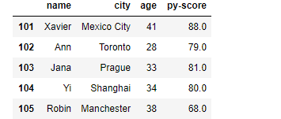

1.Display only first two rows

2.Display only last two rows

3.Extract the py-score of Toronto column.

4.display of loc of last row

5.Calculate mean, min, max, standard deviation.

6. Print the basic stats using describe() method

1. **Implement a program, to read the CSV file for the given snapshot and perform the given operations:**

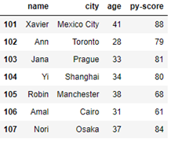

a. Display the index and columns

b. modify the labels 101 to 107 to 10 to 17.

c. Display the shape, size, ndimensional values

d. Implement NumPy slicing of array to get the output displayed below:

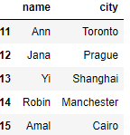

1. **Implement a program to create a Data Frame which contains data given below:**

